**CST-256 Design Report Template**

|  |  |  |
| --- | --- | --- |
| **Topic:** | *Milestone 5: Job Match Module* | |
| **Date:** | *May 16, 2021* | |
| **Revision:** | *5.0* | |
| **Team:** | 1. *Cameron Deao* | |
| 1. Mercedes Thigpen | |
| 1. Zachary Gardner | |
|  | |
| **Weekly Team Status Summary:** | |  |  |  |  | | --- | --- | --- | --- | | **User Story** | **Team**  **Member** | **Hours**  **Worked** | **Hours Remaining** | | *Preparing programming environment, design report. Database. design.* | *Zachary Gardner* | *8* |  | | *Github repository, initial project structure, class design, Database design.* | *Cameron Deao* | *10* |  | | *Design report, views, blade views.* | *Mercedes Thigpen* | *10* |  | |  |  |  |  | |  |  |  |  | |  |  |  |  | |  |  |  |  | |  |  |  |  | |  |  |  |  | |  |  |  |  | |  |  |  |  | |  |  |  |  | |  |  |  |  | | |
| **GIT URL:** | *https://github.com/cmdeao/CST-256-CLC/tree/Milestone5-Submission* | |
| **Screencast URL:** | *https://www.youtube.com/watch?v=AUkkG0Fyynw* | |
| **Peer Review:** | *Y* | We acknowledge that our team has reviewed this report and we agree to the approach we are all taking. |

**Design Documentation**

**Install Instructions:**

*Download and unzip project folder.*

*To view in Eclipse: File -> Import -> Existing Projects into Workspace -> Select Root Directory -> Finish*

**General Technical Approach:**

*As a team we’ll be creating a Professional Networking application. The project will be built within Eclipse and will leverage the open-source PHP framework Laravel alongside Composer.*

**Key Technical Design Decisions:**

*The project will be built utilizing the PHP, HTML, CSS, and JavaScript languages. Alongside the leveraged frameworks, the team will utilize GitHub as the project repository and Sourcetree for version control. Team members will create separate branches during milestone development and merge them into the ‘master’ branch through the use of pull requests.*

**ER Diagram:**

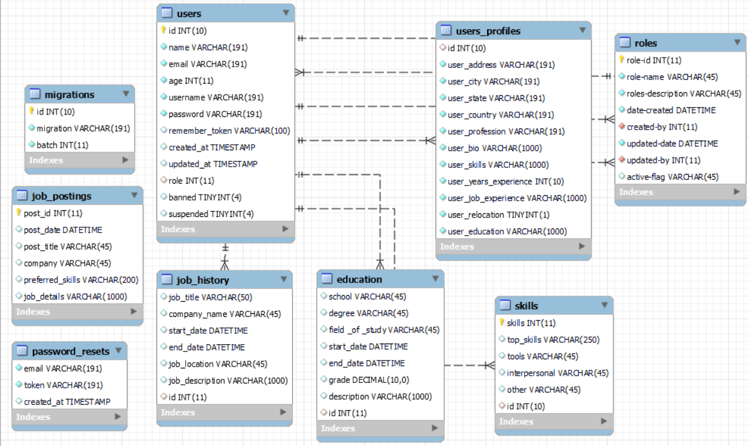

**DDL Scripts:**

*-- phpMyAdmin SQL Dump*

*-- version 4.9.5*

*-- https://www.phpmyadmin.net/*

*--*

*-- Host: localhost:3306*

*-- Generation Time: May 13, 2021 at 03:25 PM*

*-- Server version: 5.7.24*

*-- PHP Version: 7.4.1*

*SET SQL_MODE = "NO_AUTO_VALUE_ON_ZERO";*

*SET AUTOCOMMIT = 0;*

*START TRANSACTION;*

*SET time_zone = "+00:00";*

*/*!40101 SET @OLD_CHARACTER_SET_CLIENT=@@CHARACTER_SET_CLIENT */;*

*/*!40101 SET @OLD_CHARACTER_SET_RESULTS=@@CHARACTER_SET_RESULTS */;*

*/*!40101 SET @OLD_COLLATION_CONNECTION=@@COLLATION_CONNECTION */;*

*/*!40101 SET NAMES utf8mb4 */;*

*--*

*-- Database: `256-clc`*

*--*

*-- --------------------------------------------------------*

*--*

*-- Table structure for table `education`*

*--*

*CREATE TABLE `education` (*

*`school` varchar(45) DEFAULT NULL,*

*`degree` varchar(45) DEFAULT NULL,*

*`field _of _study` varchar(45) DEFAULT NULL,*

*`start_date` datetime DEFAULT NULL,*

*`end_date` datetime DEFAULT NULL,*

*`grade` decimal(10,0) DEFAULT NULL,*

*`description` varchar(1000) DEFAULT NULL,*

*`id` int(11) DEFAULT NULL*

*) ENGINE=InnoDB DEFAULT CHARSET=utf8;*

*--*

*-- Dumping data for table `education`*

*--*

*INSERT INTO `education` (`school`, `degree`, `field _of _study`, `start_date`, `end_date`, `grade`, `description`, `id`) VALUES*

*('suu', 'bachelors', 'accounting', NULL, NULL, '4', NULL, 9);*

*-- --------------------------------------------------------*

*--*

*-- Table structure for table `job_application`*

*--*

*CREATE TABLE `job_application` (*

*`user_id` int(11) NOT NULL,*

*`application_id` int(11) NOT NULL,*

*`job_post_id` int(11) NOT NULL,*

*`applicant_name` varchar(45) NOT NULL,*

*`user_address` varchar(100) NOT NULL,*

*`user_city` varchar(100) NOT NULL,*

*`user_state` varchar(45) NOT NULL,*

*`user_country` varchar(45) NOT NULL,*

*`user_profession` varchar(45) NOT NULL,*

*`user_skills` varchar(500) NOT NULL,*

*`user_years_experience` int(11) NOT NULL,*

*`user_job_experience` varchar(500) NOT NULL,*

*`user_relocation` tinyint(1) NOT NULL,*

*`user_education` varchar(500) NOT NULL*

*) ENGINE=InnoDB DEFAULT CHARSET=utf8;*

*-- --------------------------------------------------------*

*--*

*-- Table structure for table `job_history`*

*--*

*CREATE TABLE `job_history` (*

*`job_title` varchar(50) DEFAULT NULL,*

*`company_name` varchar(45) DEFAULT NULL,*

*`start_date` datetime DEFAULT NULL,*

*`end_date` datetime DEFAULT NULL,*

*`job_location` varchar(45) DEFAULT NULL,*

*`job_description` varchar(1000) DEFAULT NULL,*

*`id` int(11) DEFAULT NULL*

*) ENGINE=InnoDB DEFAULT CHARSET=utf8;*

*-- --------------------------------------------------------*

*--*

*-- Table structure for table `job_postings`*

*--*

*CREATE TABLE `job_postings` (*

*`post_id` int(11) NOT NULL,*

*`post_date` datetime DEFAULT NULL,*

*`post_title` varchar(45) DEFAULT NULL,*

*`company` varchar(45) DEFAULT NULL,*

*`preferred_skills` varchar(200) DEFAULT NULL,*

*`job_details` varchar(1000) DEFAULT NULL*

*) ENGINE=InnoDB DEFAULT CHARSET=utf8;*

*-- --------------------------------------------------------*

*--*

*-- Table structure for table `migrations`*

*--*

*CREATE TABLE `migrations` (*

*`id` int(10) UNSIGNED NOT NULL,*

*`migration` varchar(191) COLLATE utf8mb4_unicode_ci NOT NULL,*

*`batch` int(11) NOT NULL*

*) ENGINE=InnoDB DEFAULT CHARSET=utf8mb4 COLLATE=utf8mb4_unicode_ci;*

*-- --------------------------------------------------------*

*--*

*-- Table structure for table `password_resets`*

*--*

*CREATE TABLE `password_resets` (*

*`email` varchar(191) COLLATE utf8mb4_unicode_ci NOT NULL,*

*`token` varchar(191) COLLATE utf8mb4_unicode_ci NOT NULL,*

*`created_at` timestamp NULL DEFAULT NULL*

*) ENGINE=InnoDB DEFAULT CHARSET=utf8mb4 COLLATE=utf8mb4_unicode_ci;*

*-- --------------------------------------------------------*

*--*

*-- Table structure for table `roles`*

*--*

*CREATE TABLE `roles` (*

*`role-id` int(11) NOT NULL,*

*`role-name` varchar(45) NOT NULL,*

*`roles-description` varchar(45) NOT NULL,*

*`date-created` datetime NOT NULL,*

*`created-by` int(11) NOT NULL,*

*`updated-date` datetime NOT NULL,*

*`updated-by` int(11) NOT NULL,*

*`active-flag` varchar(45) DEFAULT NULL*

*) ENGINE=InnoDB DEFAULT CHARSET=utf8;*

*-- --------------------------------------------------------*

*--*

*-- Table structure for table `skills`*

*--*

*CREATE TABLE `skills` (*

*`skills` int(11) NOT NULL,*

*`top_skills` varchar(250) DEFAULT NULL,*

*`tools` varchar(45) DEFAULT NULL,*

*`interpersonal` varchar(45) DEFAULT NULL,*

*`other` varchar(45) DEFAULT NULL,*

*`id` int(10) DEFAULT NULL*

*) ENGINE=InnoDB DEFAULT CHARSET=utf8;*

*--*

*-- Dumping data for table `skills`*

*--*

*INSERT INTO `skills` (`skills`, `top_skills`, `tools`, `interpersonal`, `other`, `id`) VALUES*

*(1, 'accounting', 'laptop', 'speech', 'mountain biking', 9);*

*-- --------------------------------------------------------*

*--*

*-- Table structure for table `users`*

*--*

*CREATE TABLE `users` (*

*`id` int(10) NOT NULL,*

*`name` varchar(191) COLLATE utf8mb4_unicode_ci NOT NULL,*

*`email` varchar(191) COLLATE utf8mb4_unicode_ci NOT NULL,*

*`age` int(11) NOT NULL,*

*`username` varchar(191) COLLATE utf8mb4_unicode_ci NOT NULL,*

*`password` varchar(191) COLLATE utf8mb4_unicode_ci NOT NULL,*

*`remember_token` varchar(100) COLLATE utf8mb4_unicode_ci DEFAULT NULL,*

*`created_at` timestamp NULL DEFAULT NULL,*

*`updated_at` timestamp NULL DEFAULT NULL,*

*`role` int(11) DEFAULT NULL,*

*`banned` tinyint(4) DEFAULT '0',*

*`suspended` tinyint(4) DEFAULT '0'*

*) ENGINE=InnoDB DEFAULT CHARSET=utf8mb4 COLLATE=utf8mb4_unicode_ci;*

*--*

*-- Dumping data for table `users`*

*--*

*INSERT INTO `users` (`id`, `name`, `email`, `age`, `username`, `password`, `remember_token`, `created_at`, `updated_at`, `role`, `banned`, `suspended`) VALUES*

*(8, 'zach', 'zach@gmail.com', 29, 'tobias', 'password', NULL, NULL, NULL, NULL, 0, 0),*

*(9, 'josh', 'osh@gmail.com', 30, 'jkg', 'password', NULL, NULL, NULL, NULL, 0, 0);*

*-- --------------------------------------------------------*

*--*

*-- Table structure for table `users_profiles`*

*--*

*CREATE TABLE `users_profiles` (*

*`id` int(10) DEFAULT NULL,*

*`user_address` varchar(191) CHARACTER SET utf8mb4 COLLATE utf8mb4_unicode_ci NOT NULL,*

*`user_city` varchar(191) CHARACTER SET utf8mb4 COLLATE utf8mb4_unicode_ci NOT NULL,*

*`user_state` varchar(191) CHARACTER SET utf8mb4 COLLATE utf8mb4_unicode_ci NOT NULL,*

*`user_country` varchar(191) CHARACTER SET utf8mb4 COLLATE utf8mb4_unicode_ci NOT NULL,*

*`user_profession` varchar(191) CHARACTER SET utf8mb4 COLLATE utf8mb4_unicode_ci NOT NULL,*

*`user_bio` varchar(1000) CHARACTER SET utf8mb4 COLLATE utf8mb4_unicode_ci NOT NULL,*

*`user_skills` varchar(1000) CHARACTER SET utf8mb4 COLLATE utf8mb4_unicode_ci NOT NULL,*

*`user_years_experience` int(10) NOT NULL,*

*`user_job_experience` varchar(1000) NOT NULL,*

*`user_relocation` tinyint(1) NOT NULL,*

*`user_education` varchar(1000) NOT NULL*

*) ENGINE=InnoDB DEFAULT CHARSET=utf8;*

*--*

*-- Indexes for dumped tables*

*--*

*--*

*-- Indexes for table `education`*

*--*

*ALTER TABLE `education`*

*ADD KEY `education_idx` (`id`);*

*--*

*-- Indexes for table `job_application`*

*--*

*ALTER TABLE `job_application`*

*ADD PRIMARY KEY (`user_id`,`application_id`),*

*ADD KEY `job_post_idx` (`job_post_id`),*

*ADD KEY `user_id_app_id_idx` (`application_id`);*

*--*

*-- Indexes for table `job_history`*

*--*

*ALTER TABLE `job_history`*

*ADD KEY `job_history_user_id_idx` (`id`);*

*--*

*-- Indexes for table `job_postings`*

*--*

*ALTER TABLE `job_postings`*

*ADD PRIMARY KEY (`post_id`);*

*--*

*-- Indexes for table `migrations`*

*--*

*ALTER TABLE `migrations`*

*ADD PRIMARY KEY (`id`);*

*--*

*-- Indexes for table `password_resets`*

*--*

*ALTER TABLE `password_resets`*

*ADD KEY `password_resets_email_index` (`email`);*

*--*

*-- Indexes for table `roles`*

*--*

*ALTER TABLE `roles`*

*ADD PRIMARY KEY (`role-id`),*

*ADD KEY `updated-by_idx` (`updated-by`),*

*ADD KEY `created-by_idx` (`created-by`);*

*--*

*-- Indexes for table `skills`*

*--*

*ALTER TABLE `skills`*

*ADD PRIMARY KEY (`skills`),*

*ADD KEY `user_skills_id_idx` (`id`);*

*--*

*-- Indexes for table `users`*

*--*

*ALTER TABLE `users`*

*ADD PRIMARY KEY (`id`),*

*ADD KEY `role_idx` (`role`);*

*--*

*-- Indexes for table `users_profiles`*

*--*

*ALTER TABLE `users_profiles`*

*ADD KEY `user-user-id` (`id`);*

*--*

*-- AUTO_INCREMENT for dumped tables*

*--*

*--*

*-- AUTO_INCREMENT for table `migrations`*

*--*

*ALTER TABLE `migrations`*

*MODIFY `id` int(10) UNSIGNED NOT NULL AUTO_INCREMENT;*

*--*

*-- AUTO_INCREMENT for table `users`*

*--*

*ALTER TABLE `users`*

*MODIFY `id` int(10) NOT NULL AUTO_INCREMENT, AUTO_INCREMENT=10;*

*--*

*-- Constraints for dumped tables*

*--*

*--*

*-- Constraints for table `education`*

*--*

*ALTER TABLE `education`*

*ADD CONSTRAINT `education` FOREIGN KEY (`id`) REFERENCES `users` (`id`) ON DELETE NO ACTION ON UPDATE NO ACTION;*

*--*

*-- Constraints for table `job_application`*

*--*

*ALTER TABLE `job_application`*

*ADD CONSTRAINT `user_id` FOREIGN KEY (`user_id`) REFERENCES `users_profiles` (`id`) ON DELETE NO ACTION ON UPDATE NO ACTION,*

*ADD CONSTRAINT `user_id2` FOREIGN KEY (`user_id`) REFERENCES `users` (`id`) ON DELETE NO ACTION ON UPDATE NO ACTION,*

*ADD CONSTRAINT `users_id_app_id` FOREIGN KEY (`application_id`) REFERENCES `users` (`id`) ON DELETE NO ACTION ON UPDATE NO ACTION,*

*ADD CONSTRAINT `users_pro_app_id` FOREIGN KEY (`application_id`) REFERENCES `users_profiles` (`id`) ON DELETE NO ACTION ON UPDATE NO ACTION;*

*--*

*-- Constraints for table `job_history`*

*--*

*ALTER TABLE `job_history`*

*ADD CONSTRAINT `user_job_history` FOREIGN KEY (`id`) REFERENCES `users` (`id`) ON DELETE NO ACTION ON UPDATE NO ACTION;*

*--*

*-- Constraints for table `roles`*

*--*

*ALTER TABLE `roles`*

*ADD CONSTRAINT `created-by` FOREIGN KEY (`created-by`) REFERENCES `users` (`id`) ON DELETE NO ACTION ON UPDATE NO ACTION,*

*ADD CONSTRAINT `updated-by` FOREIGN KEY (`updated-by`) REFERENCES `users` (`id`) ON DELETE NO ACTION ON UPDATE NO ACTION;*

*--*

*-- Constraints for table `skills`*

*--*

*ALTER TABLE `skills`*

*ADD CONSTRAINT `user_skills_id` FOREIGN KEY (`id`) REFERENCES `users` (`id`) ON DELETE NO ACTION ON UPDATE NO ACTION;*

*--*

*-- Constraints for table `users`*

*--*

*ALTER TABLE `users`*

*ADD CONSTRAINT `role` FOREIGN KEY (`role`) REFERENCES `roles` (`role-id`) ON DELETE NO ACTION ON UPDATE NO ACTION;*

*--*

*-- Constraints for table `users_profiles`*

*--*

*ALTER TABLE `users_profiles`*

*ADD CONSTRAINT `user-user-id` FOREIGN KEY (`id`) REFERENCES `users` (`id`) ON DELETE NO ACTION ON UPDATE NO ACTION;*

*COMMIT;*

*/*!40101 SET CHARACTER_SET_CLIENT=@OLD_CHARACTER_SET_CLIENT */;*

*/*!40101 SET CHARACTER_SET_RESULTS=@OLD_CHARACTER_SET_RESULTS */;*

*/*!40101 SET COLLATION_CONNECTION=@OLD_COLLATION_CONNECTION */;*

**Sitemap Diagram:**

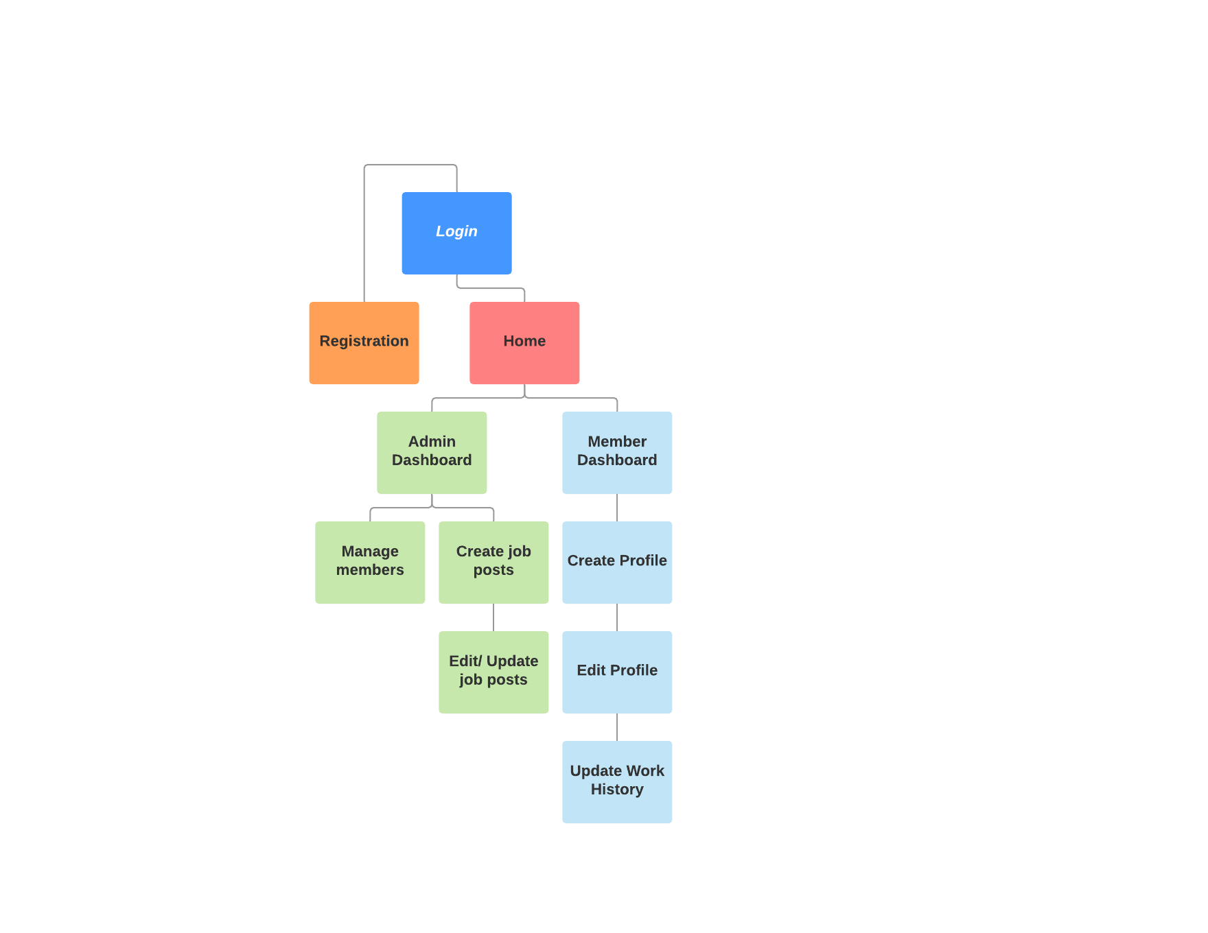

**Security Design:**

*Authentication and authorization will be achieved through the service classes and the Laravel framework. User submitted data will be stored within the appropriate tables of the database, and a form of encryption will be introduced to securely store passwords.*

**Third Party Interface Design:**

*Currently no Third Party Service Interface APIs are planned to be consumed. As planning and development progresses various options may be leveraged.*

**Flowcharts:**

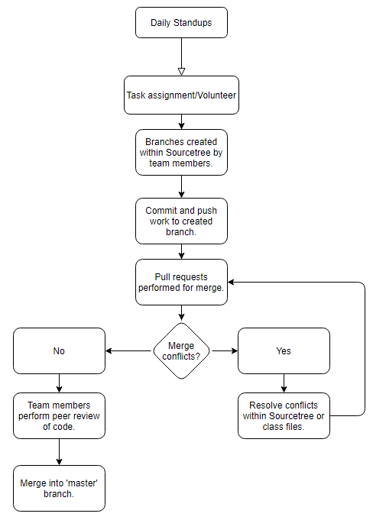

**User Interface Diagrams:**

*Login*

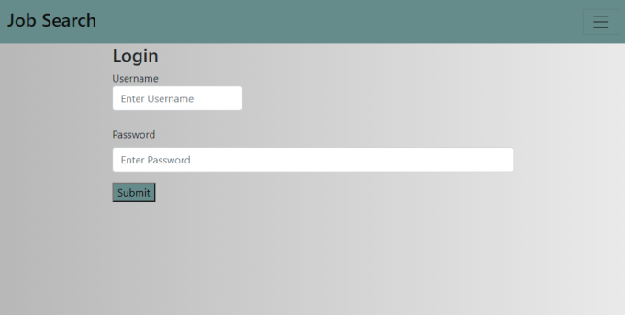

*Registration*

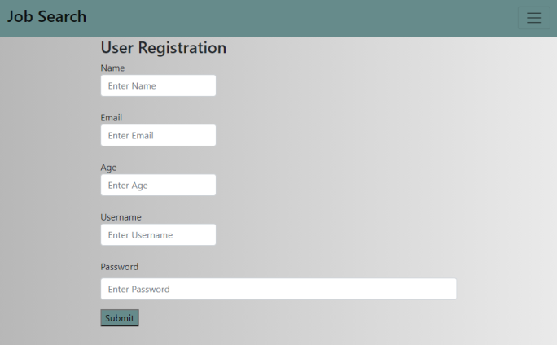

*Create Job Posting*

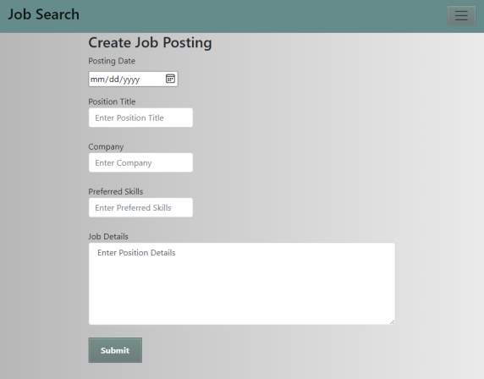

*Edit Job Posting*

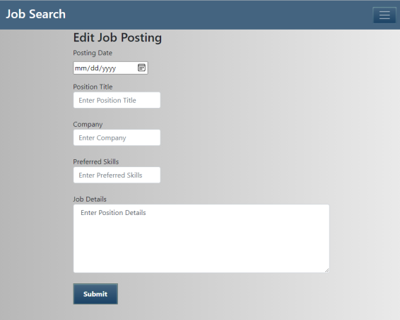

*Update Work History Page*

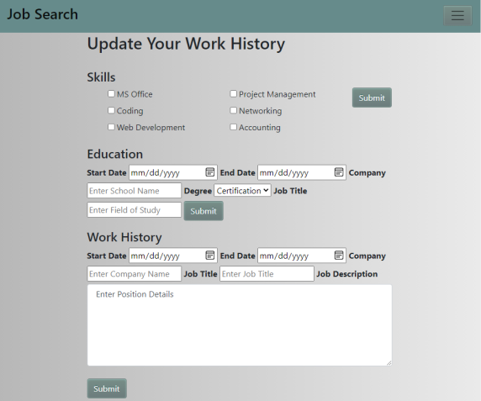

**Class Diagrams:**

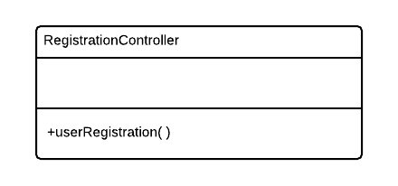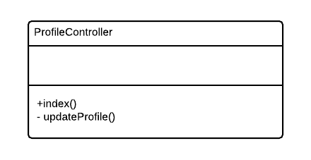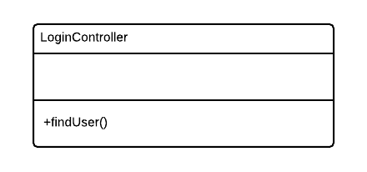

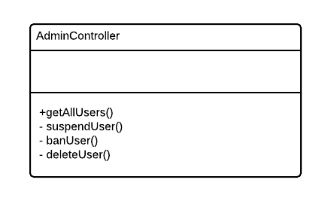

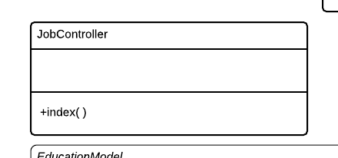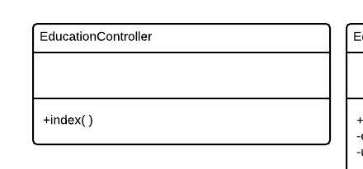

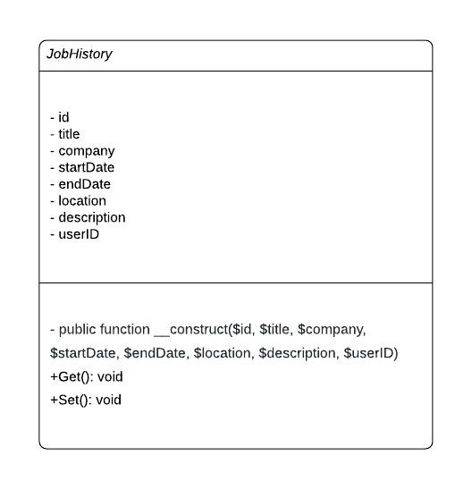

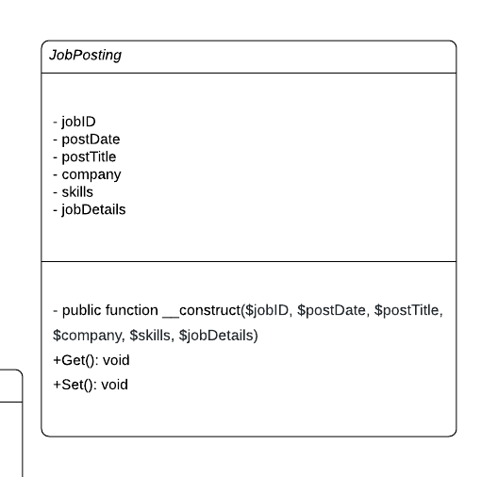

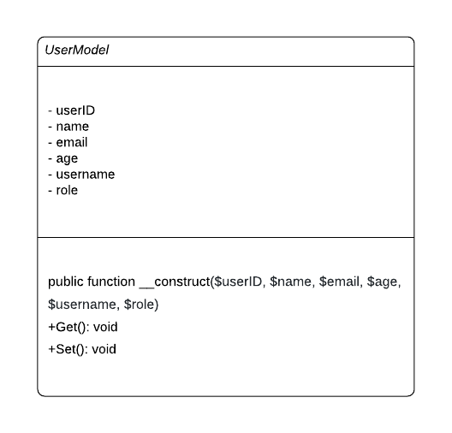

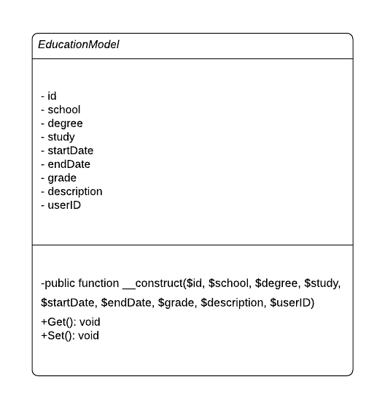

**Pseudo Code:**

*N/A – Currently no pseudo code exists within the application. This section will be updated as necessary as we move further into production and development.*

**Other Documentation:**

*N/A – Currently no additional drawings, storyboards, or schedules exist. This section will be updated as necessary as we move further into production and development.*